|  |  |  |  |  |  |
| --- | --- | --- | --- | --- | --- |
| Str +7 | Dex +5 | Con +3 | Int NA | Wis NA | Cha NA |

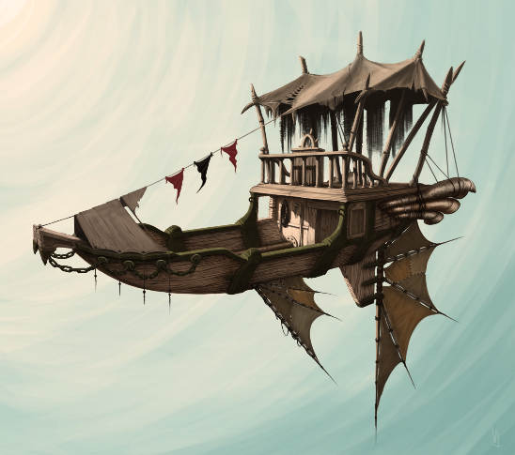

Air Ship (Unaligned)

AC: 15

Speed Flying: 100

Speed Water: 50

Size: 45ft Bow to Stern; 15ft Port to Starboard

2 floors (main deck, gun deck, and poop deck)

HP: 892 _________________

-------------------------------------------

Saving Throws: STR +9

Skill Proficiencies: Intimidation +10,

Immunities: Poison, Cold, Psychic,

Vulnerabilities: Fire, Acid

**Traits**

**Cargo:** This ship can carry up to 1000lbs of additional cargo without effect. This weight excludes starting crew, weapons, and equipment. If the cargo exceeds 1000lbs the ship cannot climb. At 1100lbs the ship will start to drop at a speed of 5 (plus an additional 5 for every 100lbs).

**Nitrous Boost.** Once per day you can add Nitrous to your motor to give you a speed boost to 300 for 10 minutes. After 10 minutes the ship must make a DC 10 saving throw every minute or damage the Terrastone or the motor (50/50). The boost speed is limited to 200 if the cargo is within 10% of its max limit and can be used to keep the ship aloft for 10 minutes if cargo is above the max limit up to 1500lbs.

**Dive**: 2 times per day, the ship can completely cut its motor and go into a controlled dive. When this feature is implemented the ship can dive faster than a person can fall, so individuals or equipment on the deck would need to be restrained or potentially be lifted off the deck. Any person on the deck who is not strapped in or holding on to something stationary would need to make a DC 10 dexterity saving throw or be thrown from the ship.

**Silent Hover:** At any time the ships motors can go into a ultra-quiet state. To take advantage of this feature the ship needs to be moving at a speed of 10 or less and not be climbing at speeds greater than 5. This feature **can not** be applied if the ships cargo is within 10% of its max limit.

**Grapple**: If the ship has a grappling hook, the hook can be thrown a distance up to the throwers strength multiplied by 3.

If the object or creature does not want to be hooked, it must succeed a DC 13 Dexterity Saving Throw or be caught by the ship. In addition, at the end of the object or creatures turn it must make a DC 13 Strength saving throw to become un-grappled, if the object or creature’s weight is above 500lbs then the rope has a 50% chance it will break.

___________________________________________________________________________________

**Owning A Ship**

**Critical Strike:** The ship has many intricate components that could be damaged during a battle. If the ship is being attacked directly by anything that can reasonably pierce the hull or break components (magic or non magic) and the attacker rolls a Critical Hit, the ship must make a DC 13 constitution saving throw or suffer disabling damage to the part being targeted or one of the following:

Roll 1d6:

(1) **Weapons**: ex: cannon;

(2) **Rutters**: The ship cannot turn (forward, backward and vertical movement still available);

(3) **Ballasts**: Ship struggles to stay upright. Players who are not tethered or actively holding on to

something stationary must make a DC 10 Dexterity saving throw **if** the ship tips, or be thrown

from the ship;

(4) **Forward Thruster**: Ship can still climb, descend, and turn but **cannot** move forward or backwards

under its own power;

(5) **Hover mechanism**: ship starts to descend at a speed of 10 and cannot climb (forward movement

is still available). If the ship hits the ground it will take 10d12 + 30 bludgeoning damage and the

crew takes 2d6+5 bludgeoning damage.

(6a) **Engine:** the ship cannot move any direction but down.

(6b) **Engine (requires heavy artillery damage ex: cannon):** Total engine failure and the ship goes into a

free fall. If the ship hits water it will take 10d12 + 30 bludgeoning damage and the crew

takes 2d6+10 bludgeoning damage when applicable. If the ship falls more than 100 feet and

hits ground, the ship and the crew are lost (unless the crew members have abilities to prevent

death from falling), if the fall is less than 100ft it takes the same as landing in water plus the

height multiplied by 5.

**Repairs:** The ship may undergo damage while adventuring, in order for the ship to regain HP it **must** be repaired by someone proficient in tinkerers or mechanic tools. The ship regains HP at a rate of 100hp per 24 hour period.

Any damaged components can be repaired initially within 30 seconds by a DC 14 Mechanics Tools Check by someone with expertise in mechanics tools (DC 19 for someone with just proficiency). If the check fails, this check can be made again every six hours as long as a mechanic has worked at least 3 hours on the ship during that time.

If the Terrastone is damaged, the ship is inoperable until replaced.

**Landing:** The ship cannot land on solid ground until it has landing gear (Landing gear causes drag and reduces max speed to 75 and boost to 250). The ship can land safely on water as long as the water is 8 feet deep and larger than the hull of the ship. The ship can silently hover indefinitely, but will drift with the wind and must be tied off.

**Attack Options**

**Crew Attack:** All ship attacks require the action of a crew member.

**Light Cannon:** *Ranged Weapon Attack:* +5 to hit, reach 200/600 ft, one target (disadvantage on all medium, small, or tiny targets, and any perpendicular moving targets). *Hit:*(5d10 + 20) bludgeoning damage. The first attack can be fired with a single action, all subsequent attacks require one action to load and one action to fire (a bonus action are not sufficient).

**Harpoon:** *Ranged Weapon Attack:* +5 to hit, reach 75/150 ft, one target (disadvantage on all medium, small, or tiny targets, and any perpendicular moving targets). *Hit:*(2d8 +10) piercing damage. The first attack can be fired with a single action, all subsequent attacks require one action to load and one action to fire. A creature or object that is hooked by the harpoon must follow the same criteria as the grapple trait above.

**Ram: 1 per day/full repair -** *Melee Weapon Attack:* +5 to hit, reach 5 ft, one target. *Hit:*(10d12 + 30) bludgeoning damage (disadvantage on all medium, small, or tiny targets and any perpendicular moving targets). With this attack, your ship needs to save on a DC 13 Constitution saving throw or damage **itself** for half the damage taken if striking anything larger than a medium living creature. For example, if the item being rammed takes 75 points of damage and your ship fails the saving throw, your ship will also take 37 hit points of bludgeoning damage. Also, if the ship fails its saving throw this action cannot be done again until the ship has been fully repaired, or it will suffer critical damage to a ship component (See Critical Strike)